Sentiment and Lie Detection using Multinomial Naïve Bayes
Kent Roller

Introduction
Text data often provides valuable insight into how customers feel about a product or service, and has been a boon to businesses who take advantage of the data. Gains in compute power and sharp decreases in the cost of storage solutions coupled with the exponential increase in their capacity has yielded this possibility. All of this with a much lower upfront investment than what would have been required just a decade or two ago. Text data can be taken and sentiment analysis can be performed on the text to gauge how people “fee” about a certain thing. Data in text form is not relegated to being sufficient for sentiment analysis alone, as it can also be used for tasks such as lie detection. In order to make the most of the capabilities, the interested party must first perform the necessary steps to make the data ready for use with a machine learning algorithm. The type of machine learning algorithm is dependent on the task at hand, and as such there should not be a one size fits all approach considered. Here, we will look at using the multinomial naïve bayes method to train a model for classification purposes. After training the model, the model will be used to try and ‘predict’ the appropriate label for the text supplied. Two different label types will be compared, ‘sentiment’ , and ‘lie’, to gauge the effectiveness of the selected algorithm at each task.

Method
The data set consists of reviews of restaurants in the Syracuse, NY area. Each observation has been manually labeled prior to acquisition, with two labels per observation. The two labels are “lie” with options of ‘f’ for false or ‘t’ for true to indicate whether each review is a lie or not, and ‘sentiment’ with the options ‘n’ for negative and ‘p’ for positive. The file used was in the tsv format as trying to use the csv file caused issues. To begin the preprocessing, the data was cleaned of any potential non-ASCII characters that were in the data to prevent potential issues in the vectorization process. Following this, we then removed any forms of punctuation and forced all of the text in the data to lower case. For the vectorization, the Tfidf vectorizer was utilized. This choice was made for a couple of reasons, and they have to do with the built in functionality of the TfidfVectorizer package. One aspect of this is that the Tfidf package handles the stop words for us, as it includes a built in dictionary of stop words, and in this case, the ‘stop_words=”english” ‘ argument was passed into the function. Another possible method to handle this task is to use a dictionary as provided by part of a different package such as nltk, but this is dependent on the task and one may perform better than the other depending on the desired output and model compatibility. In this case, with the limited scope of the data set being examined, it was determined that the default English stop words dictionary was sufficient. The second aspect of the tfidf vectorizer is that it handles the word tokenization process as well during the vectorization. As such, for our purposes, the TfidfVectorizer package is a nice all in one vectorizer that can prepare our data for machine learning algorithms. The resulting output was stored in a separate variable named ‘sparse_mtx’. The last step of preparation that was taken before applying the model was mapping the labels to binary values in order to have numeric representation of the values. For the label “lie”, the true label was mapped to 1 and the false label was mapped to 0. Likewise, for the sentiment label the ‘positive’ label was mapped to 1 and the ‘negative’ label was mapped to 0. For the model selection, we have chosen Multinomial Naïve Bayes using 10-Fold Cross Validation.

Results
To begin the comparison both models were trained using 10-fold cross validation. We wanted to know how the model performed during this stage in terms of the model’s accuracy with its predictions. The goal here is to determine what performance difference if any exist between the classification process for sentiment prediction and lie prediction using the text data.

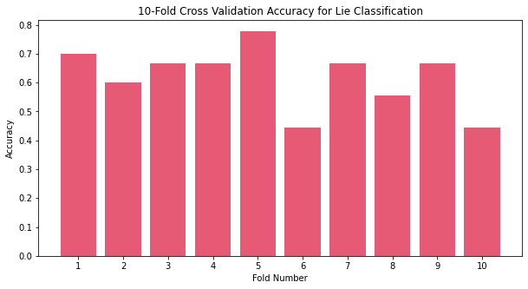
Fig 1.0 Per Fold Accuracy for Lie Classification using Multinomial Naïve Bayes
Figure 1.0 shows the per fold accuracy for lie classification using the multinomial naïve bayes model. The graph shows a fairly large range for accuracy for the model, with lows at or below 50% accuracy and highs close to 80% accuracy. The average for the lie classification was 61.89%, which is slightly better than random guessing at 50% when presented with a binary option. It should be noted that defaults for the model were used, and further hyper-parameter tuning was not performed as the goal here is to obtain a baseline performance between the two labels.

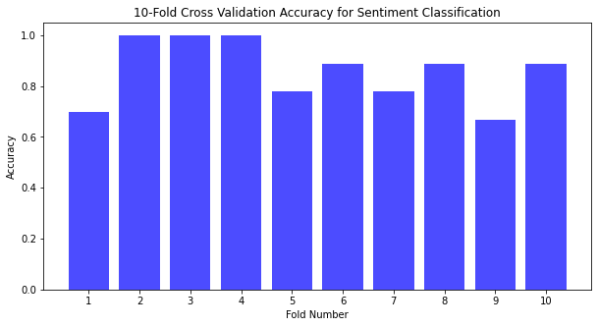
Fig 1.1 Per Fold Accuracy for Sentiment Classification using Multinomial Naïve Bayes
Fig 1.1 shows the per fold accuracy for sentiment classification using the multinomial naïve bayes model. Here we can observe a similar variation between the low and high values for the label classification task, however the accuracy values are much higher. The high values for this method are close to 100% accuracy and the low values are ~70% accuracy. This, as a result, yields a much higher average accuracy value at 85.89% accuracy, much higher than when compared with the lie classification model. This indicates that overall, at least, without further tuning, that the multinomial naïve bayes model is much more well suited to sentiment prediction than it to lie prediction when tested against the same text data. It should be noted that the data set used here was small, as even the sparse matrix that resulted from the total wordset only had dimensions of (92,1272). While this is not a tiny dataset by traditional standards, in terms of text data and the dictionaries that can result from the vectorization process, this is small. All of this is to say that when the same method is applied to a much larger dataset the outcome may vary, and with substantial training data lie prediction may improve. However, this it of itself brings up a distinction between the ease with which each task could be completed. If sentiment prediction is the goal, a relatively small training set used with the proper methods (cross validation for instance) can yield impressive results. On the other hand, with the same training set and methods, lie detection performance is fairly poor. This suggests that if lie detection was the end goal for the project, then a substantially larger dataset would have to be used for training. This further suggests that any development around a lie prediction platform would incur a much higher operational cost when compared to sentiment detection due to increase in needed data and the increase in compute power/time to process the data/model.

Top 20 Indicative Words for Lie Classification:
['food' 'restaurant' 'best' 'great' 'service' 'went' 'minutes' 'place'
'like' 'experience' 'ordered' 'plate' 'definitely' 'want' 'good' 'cold'
'dishes' 'menu' 'friends' 'pizza']
Fig 1.2 Top 20 Indicative Word List for Lie Classification Method
In figure 1.2 a list of the top 20 most indicative words for lie classification can be observed. And, as may be noticeable, many of the words make little sense when trying to think about how language is used when lying. Examples like “pizza”, “best”, “food”, “friends” are rather humorous when considering the context of the list, but not as informative as one might initially hope.

Top 20 Indicative Words for Sentiment Classification
['restaurant' 'food' 'place' 'went' 'minutes' 'ordered' 'terrible' 'salad'
'dishes' 'bad' 'just' 'order' 'good' 'pizza' 'came' 'wait' 'waiter'
'come' 'service' 'like']
Fig 1.3 Top 20 Indicative Word List for Sentiment Classification Method
In figure 1.3 a list of the top 20 most indicative words for sentiment classification can be observed. Here we can see many of the same words as shown in the lie classification method, such as “restaurant”, “food”, “good”, and “like”. This reinforces the prior belief that the model did not pick up on words that were truly significant in being able to predict lie labels, however, using many of the same words the model was able to perform fairly well in sentiment prediction. It should be noted here that the word list were generated using log probabilities. This method was chosen as Multinomial Naïve Bayes, compared to other methods of Naïve Bayes, utilizes frequency counts in determining the importance of a word. As such, since the frequency counts are what are being weighted for importance, we can use log probabilities of each of the frequencies to determine a relative score. This score is then used to determine the 20 most “weighted” words in the text data.

Conclusion
Text data can generate a wealth of knowledge regarding customer opinions and feelings towards business and enterprise operations. Sentiment analysis allows us to gain this insight, but what about other text classification problems? In an attempt to answer this, we applied multinomial naïve bayes to a collection of text in the form of restaurant reviews across two labels, sentiment and lies. The sentiment analysis performed well with the naïve bayes model out of the box returning an average accuracy of 85.89% in 10-Fold Cross Validation. The lie analysis performed markedly worse at 61.89% accuracy in 10-Fold Cross Validation. This suggests that with a minimal dataset sentiment prediction is possible if a high degree of accuracy is not required. However, attempting to perform lie detection with same minimal dataset is not nearly as effective, and suggests that a heavy amount of work would be required to obtain a similar accuracy.

